**Section 1(HTML Assignment):**

1. mkdir Assignments

cd Assignments

1. 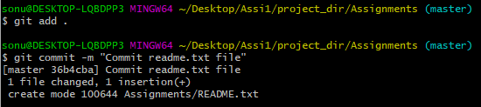
2. git branch html-assignments
3. git checkout html-assignments
4. 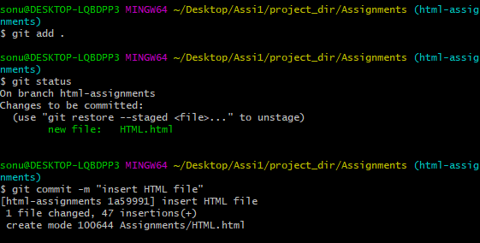
5. 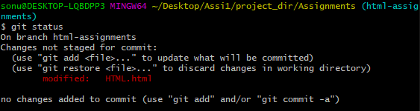
6. 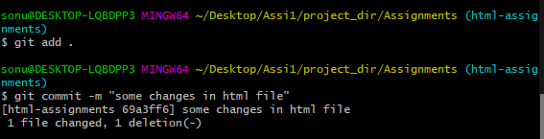
7. git checkout master
8. 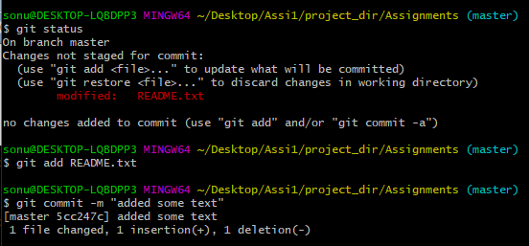
9. git checkout html-assignments
10. 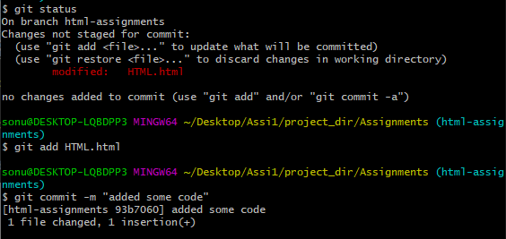
11. git checkout master
12. 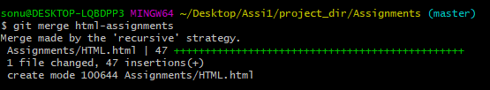
13. 17.PNGgit branch -d html-assignments

**Section 2 (CSS assignments):**

1. git branch css-assignments
2. git checkout css-assignments
3. 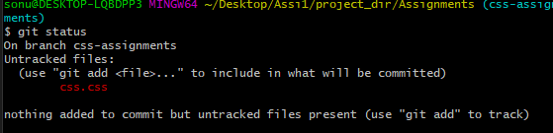
4. 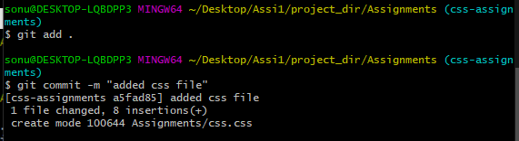
5. 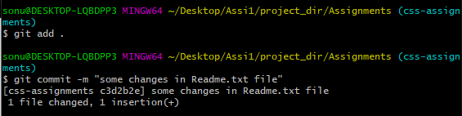
6. git checkout master
7. git add .

git commit -m "changes in line 3"

1. git checkout css-assignments
2. 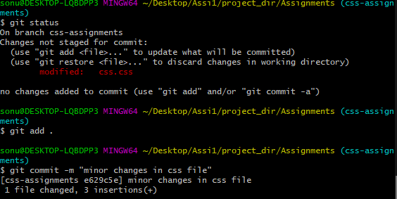
3. git checkout master
4. git merge css-assignments

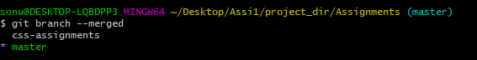

1. 23.PNG

**Section 3(javaScript assignments):**

1. git branch js-assignments
2. git checkout js-assignments
3. 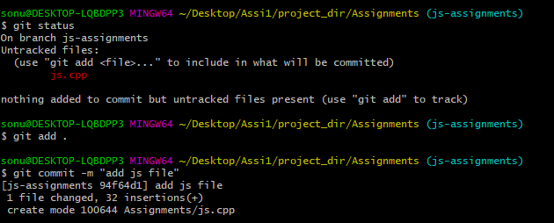
4. Make some changes and again commit it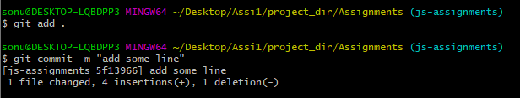
5. git checkout master
6. 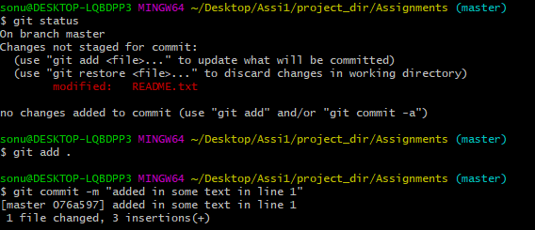
7. git checkout js-assignments
8. 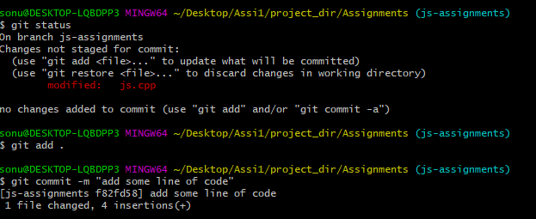
9. git checkout master
10. git merge js-assignments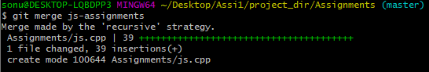
11. git branch -d js-assignments

29.PNG